Ms. Ewald’s Helpful Hints for 3/18/2020
1. Use the following link to listen to the “I Have a Dream” Speech by Martin Luther King Jr:
https://youtu.be/smEqnnklfYs
2. Use the first page of my speech as a guide for highlighting and annotating the speech:
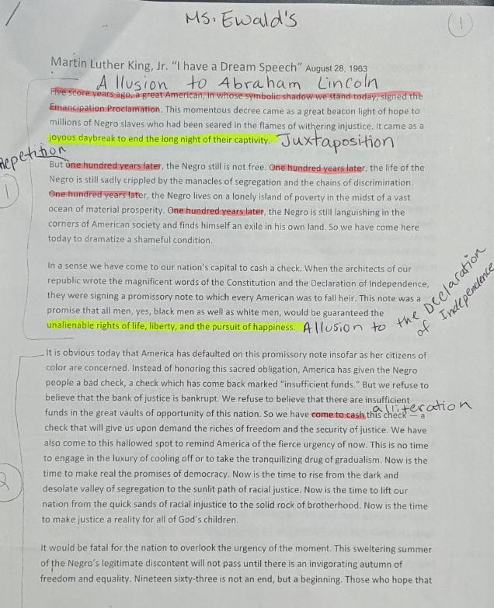
3. If you need assistance, please email me at: valiree.ewald@cobbk12.org

